13.Write a Pandas program to detect missing values of a given DataFrame. Display True or False. give simple python code
CODE:
import pandas as pd
import numpy as np
df = pd.DataFrame({
'ord_no': ['70001.0', np.nan, '70002.0', '70004.0', np.nan, '70005.0', '--', '70010.0', '70003.0', '70012.0', np.nan, '70013.0'],
'purch_amt': [150.50, 270.65, 65.26, 110.50, 948.50, 2400.60, 5760.00, '?', 12.43, 2480.40, 250.45, 3045.60],
'ord_date': ['?', '2012-09-10', np.nan, '2012-08-17', '2012-09-10', '2012-07-27', '2012-09-10', '2012-10-10', '2012-10-10', '2012-06-27', '2012-08-17', '2012-04-25'],
'customer_id': [3002, 3001, 3001, 3003, 3002, 3001, 3001, 3004, '--', 3002, 3001, 3001],
'salesman_id': [5002, 5003, '?', 5001, np.nan, 5002, 5001, '?', 5003, 5002, 5003, '--']
})
# Replace values with no useful information ('?', '--') with NaN
df = df.replace(['?', '--'], np.nan)
print(df)
Output:

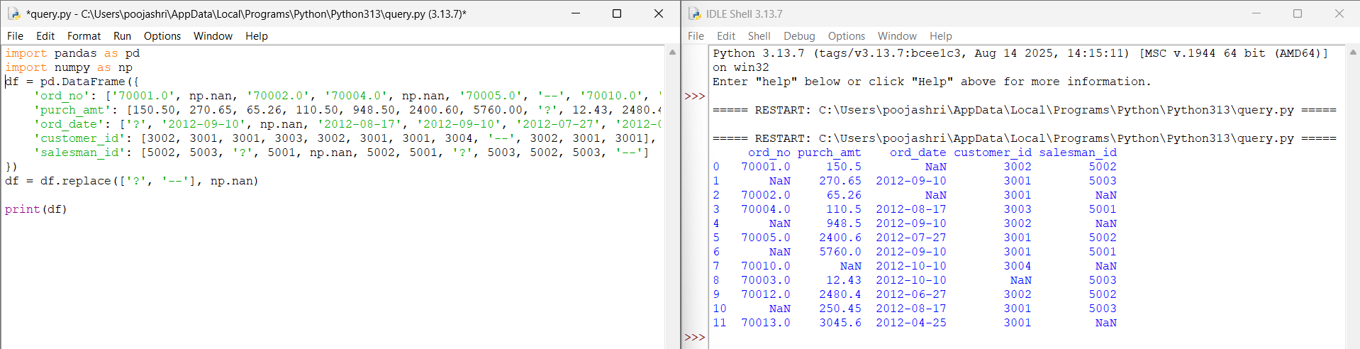

14. Write a Pandas program to find and replace the missing values in a given DataFrame which do not have any valuable information.
Code:
import pandas as pd
import numpy as np
df = pd.DataFrame({
'ord_no': [70001,np.nan,70002,70004,np.nan,70005,np.nan,70010,70003,70012,np.nan,70013],
'purch_amt': [150.50,270.65,65.26,110.50,948.50,2400.60,5760.00,1983.43,2480.40,250.45,75.29,3045.60],
'ord_date': ['2012-10-05','2012-09-10',np.nan,'2012-08-17','2012-09-10','2012-07-27','2012-09-10','2012-10-10','2012-10-10','2012-06-27','2012-08-17','2012-04-25'],
'customer_id': [3002,3001,3001,3003,3002,3001,3001,3004,3003,3002,3001,3001],
'salesman_id': [5002.0,5003.0,5001.0,np.nan,5002.0,5001.0,5001.0,np.nan,5003.0,5002.0,5003.0,np.nan]
})
print(df.isnull())

Output:
